**AAV Vector UPDATE instructions for all AAV Library Products.**

*We can take PLCB2 AAV products <https://www.abmgood.com/PLCB2-AAV-3694010.html> as an example.

**GOAL NUMBER ONE: ADDING 5 NEW FEATURES TO DROP-DOWN BOX**

Currently, AAV expression Vectors and Viruses have 14 feature selections.

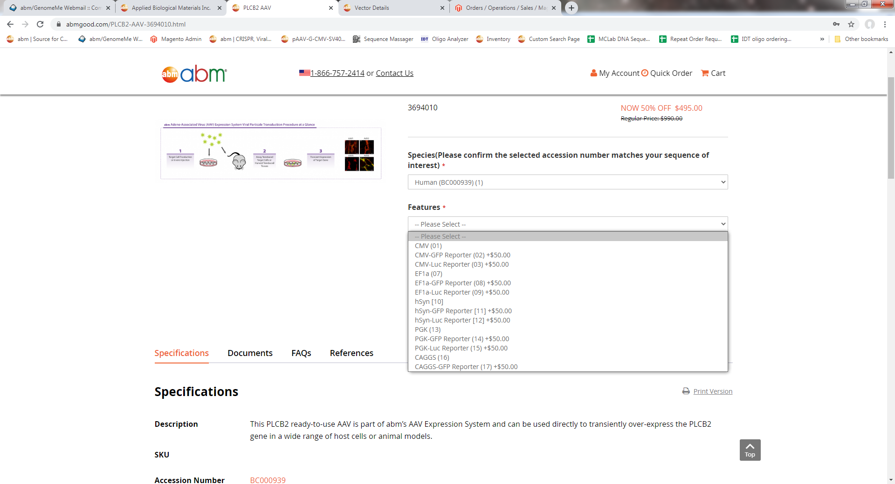

We want a total of 19 features. The highlighted 5 vector are the features that we need to **create new AAV library products and vector pages**. 创建5个新的feature, 需要添加New Product Specification 和 Vector 的网页。Accession# 19, 20, 22, 21, 18。我接下来会具体解释。

|  |
| --- |
| **AAV Expression** |
| **Features** |
| CMV (01) |
| CMV-GFP Reporter [02] |
| CMV-Luc Reporter [03] |
| CMV-CBH-GFP Reporter [19] |
|  |
| EF1a [07] |
| EF1a-GFP Reporter [08] |
| EF1a-Luc Reporter [09] |
| EF1a-CBH-GFP Reporter [20] |
|  |
| hSync [10] |
| hSync-GFP Reporter [11] |
| hSync-Luc Reporter [12] |
| hSync-CBH-GFP Reporter [22] |
|  |
| PGK [13] |
| PGK-GFP Reporter [14] |
| PGK-Luc Reporter [15] |
| PGK-CBH-GFP Reporter [21] |
|  |
| CAGGS [16] |
| CAGGS-GFP Reporter [17] |
| CAGGS-CBH-GFP Reporter [18] |

**Here’s the information to be used for these new pages on the new product page: 我发给你的Excel文件有你需要的所有信息。**You can find a lot of the information in the Excel file. I’m explaining it in detail here. 因为信息比较多 可能看懂需要很多时间 所以我在下面解释一下。每一个新的Feature 会产生新的library产品网页，Specification 需要这样添加：

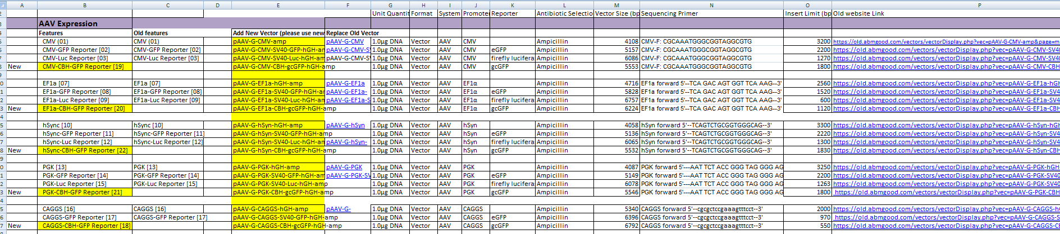

**Product Name:** (insert the Gene Name) AAV Vector (insert Species) (Feature name)

So they will be: 注意每个产品网页显示一个name， 不要把五个都加到所有的产品网页里。

名字要跟feature名字一样 注意是CMV，EF1a, hSync, PGK, 还是CAGGS

**PLCB2 AAV Vector (Human) (CMV) (CBH-GFP) for** CMV-CBH-GFP Reporter [19]

**PLCB2 AAV Vector (Human) (EF1a) (CBH-GFP) for** EF1a-CBH-GFP Reporter [20]

**PLCB2 AAV Vector (Human) (hSync) (CBH-GFP) for** hSync-CBH-GFP Reporter [22]

**PLCB2 AAV Vector (Human) (PGK) (CBH-GFP) for** PGK-CBH-GFP Reporter [21]

**PLCB2 AAV Vector (Human) (CAGGS) (CBH-GFP)** for CAGGS-CBH-GFP Reporter [18]

**Cat. No:** generate new ones using 19, 20, 22, 21 18 feature cat numbers

**Vector:**  in **Column E of excel file,** but I’ve also pasted them below.

So they are  **pAAV-G-CMV-CBH-gcGFP-hGH-amp 对应的产品feature 是** CMV-CBH-GFP Reporter [19]

**pAAV-G-EF1a-CBH-gcGFP-hGH-amp 对应的产品feature 是** EF1a-CBH-GFP Reporter [20]

**pAAV-G-hSyn-CBH-gcGFP-hGH-amp对应的产品feature 是** hSync-CBH-GFP Reporter [22]

**pAAV-G-PGK-CBH-gcGFP-hGH-amp 对应的产品feature 是** PGK-CBH-GFP Reporter [21]

**pAAV-G-CAGGS-CBH-gcGFP-hGH-amp 对应的产品feature 是** CAGGS-CBH-GFP Reporter [18]

*Please make sure the correct feature name correlates to the correct vector.

**Promoters:** see column J in excel sheet

**CMV**

**EF1a**

**hSync**

**PGK**

**CAGGS**

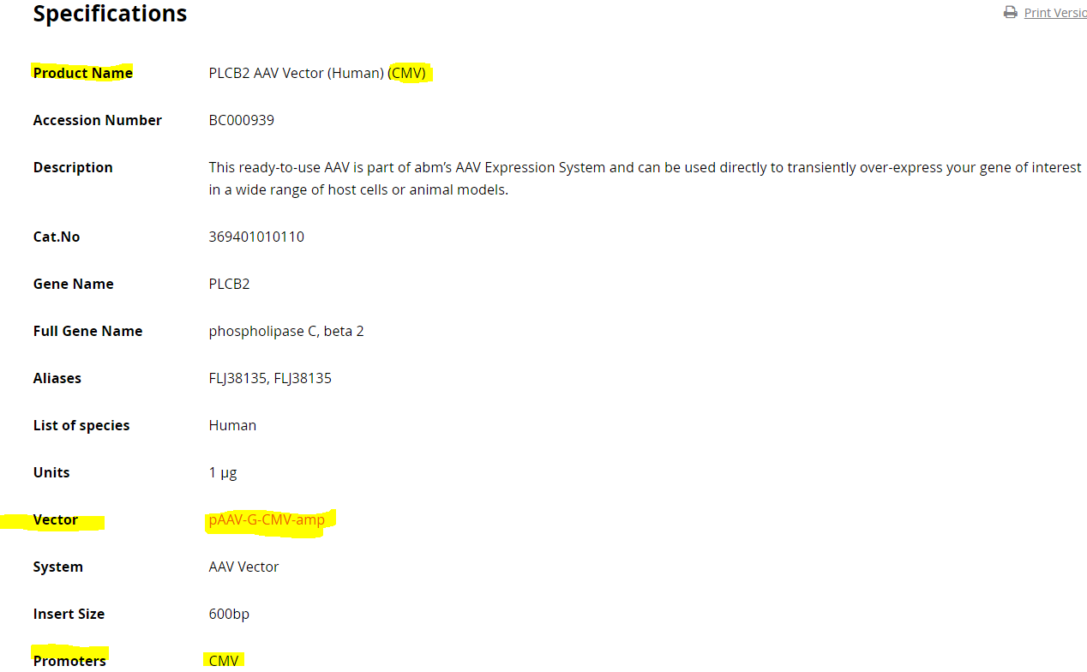

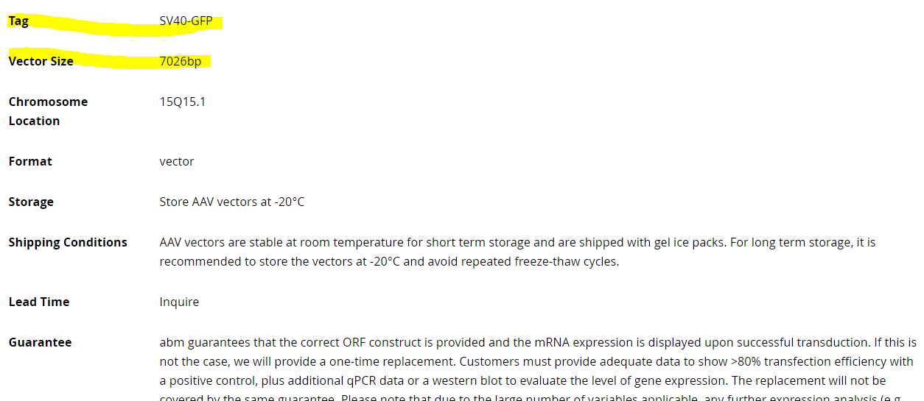

**Tag: excel 文件 Column K有写，**

**5个Vector 都是 CBH-gcGFP**

**Vector size:** excel Column M

MV-CBH-GFP Reporter [19] 5553 bp

EF1a-CBH-GFP Reporter [20] 6224 bp

hSync-CBH-GFP Reporter [22] 5532bp

PGK-CBH-GFP Reporter [21] 5546 bp

CAGGS-CBH-GFP Reporter [18] 6792 bp

Format: vector/virus/cell 如果是 （10）就是Vector

如果是 （11 到19）就是 virus

**Now, We have to make a new webpage for each of the 5 new vectors to link to, like what we’ve done for the 14 other features.** 创建新的library产品和更新完Specification之后需要创建产品所对应的新的Vector网页， 就像点击这里

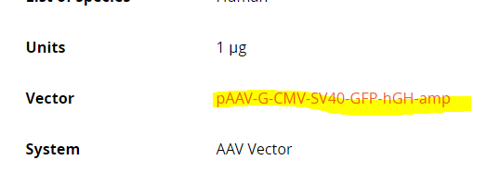

会打开这里<https://www.abmgood.com/vectormap/index/index/?name=pAAV-G-CMV-SV40-GFP-hGH-amp>。 我已经把所有Vector在旧的网站里更新了 但是因为更新没有加入新的网站 所以需要你重新加进去。信息已经发给你 （Excel 可以找得到， 图片Map以前有发给你一个大的ZIP文件。 Sequence 可以在旧的网页里找得到 但是我把所有资料和图片都写到这里了。

I’ve actually already uploaded these 5 vectors before onto the old website, but they weren’t transferred to the new website. You can copy all the Information from these older links that I’ve posted below, or find them all in the excel file. I’ve also consolidated everything here.

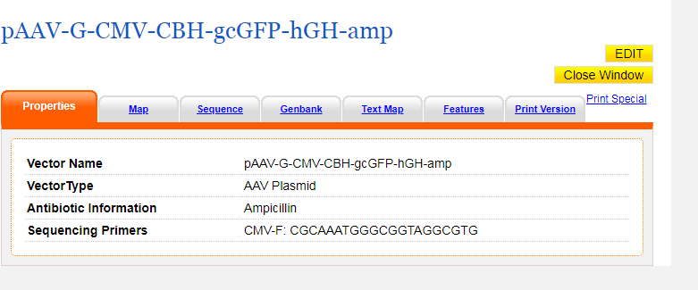

**All information you need is here, but also in excel file, or in attachment.**

**Vector name:** Column E Excel 文件里有

**Vector Type:** AAV Plasmid

**Antibioti c Information:** Ampicilin

**Sequence Primers:** Column N Excel 文件里有

**Additional Information:** No Additional Information.

MAP, Sequence can all be found in my previous emails, attachments, or by following the link to the old website.

**Here’s what the finished product will look like (information found in excel file but included all here) 更新完的Vector 网页是这样的**

**1. pAAV-G-CMV-CBH-gcGFP-hGH-amp**

Old webpage vector link that you can copy sequence and map from:

<https://old.abmgood.com/vectors/vectorDisplay.php?vec=pAAV-G-CMV-CBH-gcGFP-hGH-amp&page=prop>

**Finished product:**

|  |  |
| --- | --- |
| **Vector Name** | pAAV-G-CMV-CBH-gcGFP-hGH-amp |
| **VectorType** | AAV Plasmid |
| **Antibiotic Information** | Ampicillin |
| **Sequencing Primers** | CMV-F: CGCAAATGGGCGGTAGGCGTG |
| **Additional Information** | No Additional Information |

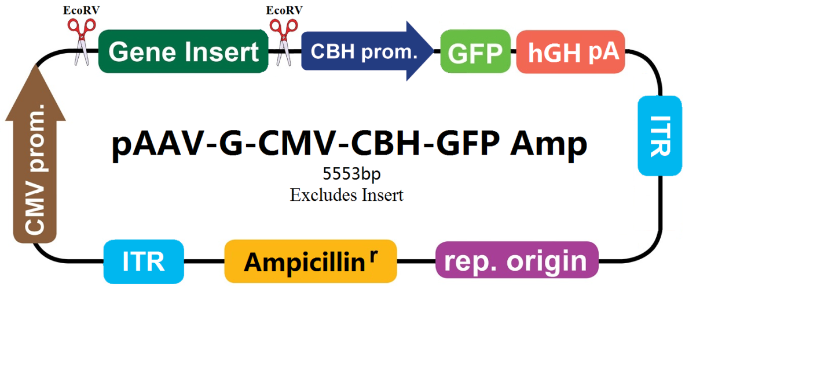

I’ve also included this photo in the attachments of previous and this email.

1 cctgcaggca gctgcgcgct cgctcgctca ctgaggccgc ccgggcgtcg ggcgaccttt  
61 ggtcgcccgg cctcagtgag cgagcgagcg cgcagagagg gagtggccaa ctccatcact  
121 aggggttcct gcggccgcCC TAGGcgttac ataacttacg gtaaatggcc cgcctggctg  
181 accgcccaac gacccccgcc cattgacgtc aataatgacg tatgttccca tagtaacgcc  
241 aatagggact ttccattgac gtcaatgggt ggagtattta cggtaaactg cccacttggc  
301 agtacatcaa gtgtatcata tgccaagtac gccccctatt gacgtcaatg acggtaaatg  
361 gcccgcctgg cattatgccc agtacatgac cttatgggac tttcctactt ggcagtacat  
421 ctacgtttag tcatcgctat taccatggtg atgcggtttt ggcagtacat caatgggcgt  
481 ggatagcggt ttgactcacg gggatttcca agtctccacc ccattgacgt caatgggagt  
541 ttgttttggc accaaaatca acgggacttt ccaaaatgtc gtaacaactc cgccccattg  
601 acgcaaatgg gcggtaggcg tgtacggtgg gaggtctata taagcagagc tcgtttagtg  
661 aaccgtcaga tcgcctggag acgccatcca cgctgttttg acctccatag aagaaccgag  
721 tttaaactcc ctatcagtga tagagatctc cctatcagtg atagagagct agcgatatca  
781 acaagtttgt acaaaaaagc tgaacgagaa acgtaaaatg atataaatat caatatatta  
841 aattagattt tgcataaaaa acagactaca taatactgta aaacacaaca tatccagtca  
901 ctatggcggc cgcattaggc accccaggct ttacacttta tgcttccggc tcgtataatg  
961 tgtggatttt gagttaggat ccgtcgagat tttcaggagc taaggaagct aaaatggaga  
1021 aaaaaatcac tggatatacc accgttgata tatcccaatg gcatcgtaaa gaacattttg  
1081 aggcatttca gtcagttgct caatgtacct ataaccagac cgttcagctg gatattacgg  
1141 cctttttaaa gaccgtaaag aaaaataagc acaagtttta tccggccttt attcacattc  
1201 ttgcccgcct gatgaatgct catccggaat tccgtatggc aatgaaagac ggtgagctgg  
1261 tgatatggga tagtgttcac ccttgttaca ccgttttcca tgagcaaact gaaacgtttt  
1321 catcgctctg gagtgaatac cacgacgatt tccggcagtt tctacacata tattcgcaag  
1381 atgtggcgtg ttacggtgaa aacctggcct atttccctaa agggtttatt gagaatatgt  
1441 ttttcgtctc agccaatccc tgggtgagtt tcaccagttt tgatttaaac gtggccaata  
1501 tggacaactt cttcgccccc gttttcacca tgggcaaata ttatacgcaa ggcgacaagg  
1561 tgctgatgcc gctggcgatt caggttcatc atgccgtttg tgatggcttc catgtcggca  
1621 gaatgcttaa tgaattacaa cagtactgcg atgagtggca gggcggggcg taaagatctg  
1681 gatccggctt actaaaagcc agataacagt atgcgtattt gcgcgctgat ttttgcggta  
1741 taagaatata tactgatatg tatacccgaa gtatgtcaaa aagaggtatg ctatgaagca  
1801 gcgtattaca gtgacagttg acagcgacag ctatcagttg ctcaaggcat atatgatgtc  
1861 aatatctccg gtctggtaag cacaaccatg cagaatgaag cccgtcgtct gcgtgccgaa  
1921 cgctggaaag cggaaaatca ggaagggatg gctgaggtcg cccggtttat tgaaatgaac  
1981 ggctcttttg ctgacgagaa caggggctgg tgaaatgcag tttaaggttt acacctataa  
2041 aagagagagc cgttatcgtc tgtttgtgga tgtacagagt gatattattg acacgcccgg  
2101 gcgacggatg gtgatccccc tggccagtgc acgtctgctg tcagataaag tctcccgtga  
2161 actttacccg gtggtgcata tcggggatga aagctggcgc atgatgacca ccgatatggc  
2221 cagtgtgccg gtctccgtta tcggggaaga agtggctgat ctcagccacc gcgaaaatga  
2281 catcaaaaac gccattaacc tgatgttctg gggaatataa atgtcaggct cccttataca  
2341 cagccagtct gcaggtcgac catagtgact ggatatgttg tgttttacag tattatgtag  
2401 tctgtttttt atgcaaaatc taatttaata tattgatatt tatatcattt tacgtttctc  
2461 gttcagcttt cttgtacaaa gtggttgata tctgactcga gTATAAGGAT GATGACGACA  
2521 AATGAGCTAG CACATAACTT ACGGTAAATG GCCCGCCTGG CTGACCGCCC AACGACCCCC  
2581 GCCCATTGAC GTCAATAGTA ACGCCAATAG GGACTTTCCA TTGACGTCAA TGGGTGGAGT  
2641 ATTTACGGTA AACTGCCCAC TTGGCAGTAC ATCAAGTGTA TCATATGCCA AGTACGCCCC  
2701 CTATTGACGT CAATGACGGT AAATGGCCCG CCTGGCATTG TGCCCAGTAC ATGACCTTAT  
2761 GGGACTTTCC TACTTGGCAG TACATCTACG TATTAGTCAT CGCTATTACC ATGGTCGAGG  
2821 TGAGCCCCAC GTTCTGCTTC ACTCTCCCCA TCTCCCCCCC CTCCCCACCC CCAATTTTGT  
2881 ATTTATTTAT TTTTTAATTA TTTTGTGCAG CGATGGGGGC GGGGGGGGGG GGGGCGCGCG  
2941 CCAGGCGGGG CGGGGCGGGG CGAGGGGCGG GGCGGGGCGA GGCGGAGAGG TGCGGCGGCA  
3001 GCCAATCAGA GCGGCGCGCT CCAAAAGTTT CCTTTTATGG CGAGGCGGCG GCGGCGGCGG  
3061 CCCTATAAAA AGCGAAGCGC GCGGCGGGCG GGAGTCGCTG CGCGCTGCCT TCGCCCCGTG  
3121 CCCCGCTCCG CCGCCGCCTC GCGCCGCCCG CCCCGGCTCT GACTGACCGC GTTACTCCCA  
3181 CAGGTGAGCG GGCGGGACGG CCCTTCTCCT CCGGGCTGTA ATTAGCTTCG AACGCCACCA  
3241 TGGTGAGCAA GGGCGAGGAG CTGTTCACCG GGGTGGTGCC CATCCTGGTC GAGCTGGACG  
3301 GCGACGTAAA CGGCCACAAG TTCAGCGTGT CCGGCGAGGG CGAGGGCGAT GCCACCTACG  
3361 GCAAGCTGAC CCTGAAGTTC ATCTGCACCA CCGGCAAGCT GCCCGTGCCC TGGCCCACCC  
3421 TCGTGACCAC CTTGACCTAC GGCGTGCAGT GCTTCGCCCG CTACCCCGAC CACATGAAGC  
3481 AGCACGACTT CTTCAAGTCC GCCATGCCCG AAGGCTACGT CCAGGAGCGC ACCATCTTCT  
3541 TCAAGGACGA CGGCAACTAC AAGACCCGCG CCGAGGTGAA GTTCGAGGGC GACACCCTGG  
3601 TGAACCGCAT CGAGCTGAAG GGCATCGACT TCAAGGAGGA CGGCAACATC CTGGGGCACA  
3661 AGCTGGAGTA CAACTACAAC AGCCACAAGG TCTATATCAC CGCCGACAAG CAGAAGAACG  
3721 GCATCAAGGT GAACTTCAAG ACCCGCCACA ACATCGAGGA CGGCAGCGTG CAGCTCGCCG  
3781 ACCACTACCA GCAGAACACC CCCATCGGCG ACGGCCCCGT GCTGCTGCCC GACAACCACT  
3841 ACCTGAGCAC CCAGTCCGCC CTGAGCAAAG ACCCCAACGA GAAGCGCGAT CACATGGTCC  
3901 TGCTGGAGTT CGTGACCGCC GCCGGGATCA CTCTCGGCAT GGACGAGCTG TACAAGTAAc  
3961 ttaaggggtg gcatccctgt gacccctccc cagtgcctct cctggccctg gaagttgcca  
4021 ctccagtgcc caccagcctt gtcctaataa aattaagttg catcattttg tctgactagg  
4081 tgtccttcta taatattatg gggtggaggg gggtggtatg gagcaagggg caagttggga  
4141 agacaacctg tagggcctgc ggggtctatt gggaaccaag ctggagtgca gtggcacaat  
4201 cttggctcac tgcaatctcc gcctcctggg ttcaagcgat tctcctgcct cagcctcccg  
4261 agttgttggg attccaggca tgcatgacca ggctcagcta atttttgttt ttttggtaga  
4321 gacggggttt caccatattg gccaggctgg tctccaactc ctaatctcag gtgatctacc  
4381 caccttggcc tcccaaattg ctgggattac aggcgtgaac cactgctccc ttccctgtcc  
4441 ttcacgtgcg gaccgagcgg ccgcaggaac ccctagtgat ggagttggcc actccctctc  
4501 tgcgcgctcg ctcgctcact gaggccgggc gaccaaaggt cgcccgacgc ccgggctttg  
4561 cccgggcggc ctcagtgagc gagcgagcgc gcagctgcct gcaggggcgc ctgatgcggt  
4621 attttctcct tacgcatctg tgcggtattt cacaccgcat acgtcaaagc aaccatagta  
4681 cgcgccctgt agcggcgcat taagcgcggc gggtgtggtg gttacgcgca gcgtgaccgc  
4741 tacacttgcc agcgccttag cgcccgctcc tttcgctttc ttcccttcct ttctcgccac  
4801 gttcgccggc tttccccgtc aagctctaaa tcgggggctc cctttagggt tccgatttag  
4861 tgctttacgg cacctcgacc ccaaaaaact tgatttgggt gatggttcac gtagtgggcc  
4921 atcgccctga tagacggttt ttcgcccttt gacgttggag tccacgttct ttaatagtgg  
4981 actcttgttc caaactggaa caacactcaa ctctatctcg ggctattctt ttgatttata  
5041 agggattttg ccgatttcgg tctattggtt aaaaaatgag ctgatttaac aaaaatttaa  
5101 cgcgaatttt aacaaaatat taacgtttac aattttatgg tgcactctca gtacaatctg  
5161 ctctgatgcc gcatagttaa gccagccccg acacccgcca acacccgctg acgcgccctg  
5221 acgggcttgt ctgctcccgg catccgctta cagacaagct gtgaccgtct ccgggagctg  
5281 catgtgtcag aggttttcac cgtcatcacc gaaacgcgcg agccgggagc tgcatgtgtc  
5341 agaggttttc accgtcatca ccgaaacgcg cgagacgaaa gggcctcgtg atacgcctat  
5401 ttttataggt taatgtcatg ataataatgg tttcttagac gtcaggtggc acttttcggg  
5461 gaaatgtgcg cggaacccct atttgtttat ttttctaaat acattcaaat atgtatccgc  
5521 tcatgagaca ataaccctga taaatgcttc aataatattg aaaaaggaag agtatgagta  
5581 ttcaacattt ccgtgtcgcc cttattccct tttttgcggc attttgcctt cctgtttttg  
5641 ctcacccaga aacgctggtg aaagtaaaag atgctgaaga tcagttgggt gcacgagtgg  
5701 gttacatcga actggatctc aacagcggta agatccttga gagttttcgc cccgaagaac  
5761 gttttccaat gatgagcact tttaaagttc tgctatgtgg cgcggtatta tcccgtattg  
5821 acgccgggca agagcaactc ggtcgccgca tacactattc tcagaatgac ttggttgagt  
5881 actcaccagt cacagaaaag catcttacgg atggcatgac agtaagagaa ttatgcagtg  
5941 ctgccataac catgagtgat aacactgcgg ccaacttact tctgacaacg atcggaggac  
6001 cgaaggagct aaccgctttt ttgcacaaca tgggggatca tgtaactcgc cttgatcgtt  
6061 gggaaccgga gctgaatgaa gccataccaa acgacgagcg tgacaccacg atgcctgtag  
6121 caatggcaac aacgttgcgc aaactattaa ctggcgaact acttactcta gcttcccggc  
6181 aacaattaat agactggatg gaggcggata aagttgcagg accacttctg cgctcggccc  
6241 ttccggctgg ctggtttatt gctgataaat ctggagccgg tgagcgtggg tctcgcggta  
6301 tcattgcagc actggggcca gatggtaagc cctcccgtat cgtagttatc tacacgacgg  
6361 ggagtcaggc aactatggat gaacgaaata gacagatcgc tgagataggt gcctcactga  
6421 ttaagcattg gtaactgtca gaccaagttt actcatatat actttagatt gatttaaaac  
6481 ttcattttta atttaaaagg atctaggtga agatcctttt tgataatctc atgaccaaaa  
6541 tcccttaacg tgagttttcg ttccactgag cgtcagaccc cgtagaaaag atcaaaggat  
6601 cttcttgaga tccttttttt ctgcgcgtaa tctgctgctt gcaaacaaaa aaaccaccgc  
6661 taccagcggt ggtttgtttg ccggatcaag agctaccaac tctttttccg aaggtaactg  
6721 gcttcagcag agcgcagata ccaaatactg ttcttctagt gtagccgtag ttaggccacc  
6781 acttcaagaa ctctgtagca ccgcctacat acctcgctct gctaatcctg ttaccagtgg  
6841 ctgctgccag tggcgataag tcgtgtctta ccgggttgga ctcaagacga tagttaccgg  
6901 ataaggcgca gcggtcgggc tgaacggggg gttcgtgcac acagcccagc ttggagcgaa  
6961 cgacctacac cgaactgaga tacctacagc gtgagctatg agaaagcgcc acgcttcccg  
7021 aagggagaaa ggcggacagg tatccggtaa gcggcagggt cggaacagga gagcgcacga  
7081 gggagcttcc agggggaaac gcctggtatc tttatagtcc tgtcgggttt cgccacctct  
7141 gacttgagcg tcgatttttg tgatgctcgt caggggggcg gagcctatgg aaaaacgcca  
7201 gcaacgcggc ctttttacgg ttcctggcct tttgctggcc ttttgctcac atgt

**2. pAAV-G-EF1a-CBH-gcGFP-hGH-amp**

Old webpage vector link that you can copy sequence and map from:

<https://old.abmgood.com/vectors/vectorDisplay.php?vec=pAAV-G-EF1a-CBH-gcGFP-hGH-amp&page=map>

**Finished product**

|  |  |
| --- | --- |
| **Vector Name** | **pAAV-G-EF1a-CBH-gcGFP-hGH-amp** |
| **VectorType** | AAV Plasmid |
| **Antibiotic Information** | Ampicillin |
| **Sequencing Primers** | EF1a forward 5'--TCA GAC AGT GGT TCA AAG--3' |
| **Additional Information** | No Additional Information |

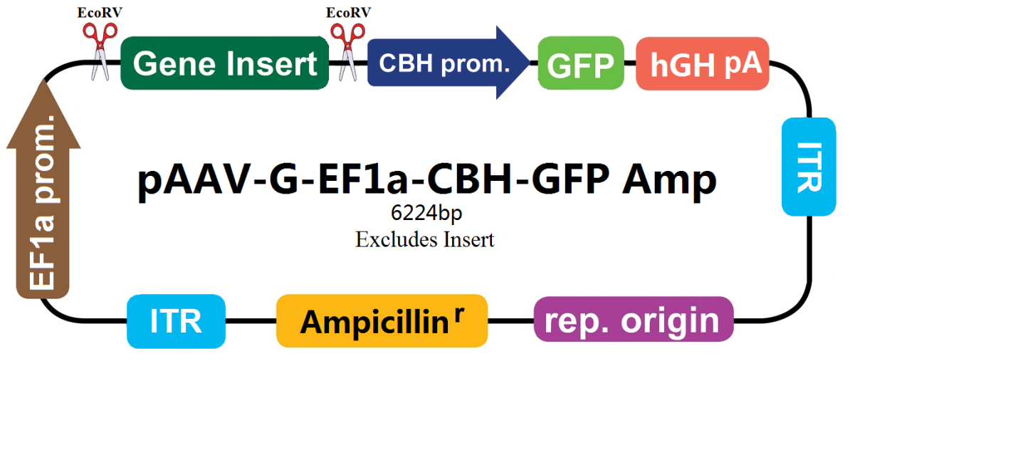

**1 cctgcaggca gctgcgcgct cgctcgctca ctgaggccgc ccgggcgtcg ggcgaccttt  
61 ggtcgcccgg cctcagtgag cgagcgagcg cgcagagagg gagtggccaa ctccatcact  
121 aggggttcct gcggccgcCC TAGGggctcc ggtgcccgtc agtgggcaga gcgcacatcg  
181 cccacagtcc ccgagaagtt ggggggaggg gtcggcaatt gaaccggtgc ctagagaagg  
241 tggcgcgggg taaactggga aagtgatgtc gtgtactggc tccgcctttt tcccgagggt  
301 gggggagaac cgtatataag tgcagtagtc gccgtgaacg ttctttttcg caacgggttt  
361 gccgccagaa cacaggtaag tgccgtgtgt ggttcccgcg ggcctggcct ctttacgggt  
421 tatggccctt gcgtgccttg aattacttcc acctggctgc agtacgtgat tcttgatccc  
481 gagcttcggg ttggaagtgg gtgggagagt tcgaggcctt gcgcttaagg agccccttcg  
541 cctcgtgctt gagttgaggc ctggcctggg cgctggggcc gccgcgtgcg aatctggtgg  
601 caccttcgcg cctgtctcgc tgctttcgat aagtctctag ccatttaaaa tttttgatga  
661 cctgctgcga cgcttttttt ctggcaagat agtcttgtaa atgcgggcca agatctgcac  
721 actggtattt cggtttttgg ggccgcgggc ggcgacgggg cccgtgcgtc ccagcgcaca  
781 tgttcggcga ggcggggcct gcgagcgcgg ccaccgagaa tcggacgggg gtagtctcaa  
841 gctggccggc ctgctctggt gcctggcctc gcgccgccgt gtatcgcccc gccctgggcg  
901 gcaaggctgg cccggtcggc accagttgcg tgagcggaaa gatggccgct tcccggccct  
961 gctgcaggga gctcaaaatg gaggacgcgg cgctcgggag agcgggcggg tgagtcaccc  
1021 acacaaagga aaagggcctt tccgtcctca gccgtcgctt catgtgactc cacggagtac  
1081 cgggcgccgt ccaggcacct cgattagttc tcgagctttt ggagtacgtc gtctttaggt  
1141 tggggggagg ggttttatgc gatggagttt ccccacactg agtgggtgga gactgaagtt  
1201 aggccagctt ggcacttgat gtaattctcc ttggaatttg ccctttttga gtttggatct  
1261 tggttcattc tcaagcctca gacagtggtt caaagttttt ttcttccatt tcaggtgtcg  
1321 tgagagctcg tttagtgaac cgtcagatcg cctggagacg ccatccacgc tgttttgacc  
1381 tccatagaag aaccgagttt aaactcccta tcagtgatag agatctccct atcagtgata  
1441 gagagctagc gatatcaaca agtttgtaca aaaaagctga acgagaaacg taaaatgata  
1501 taaatatcaa tatattaaat tagattttgc ataaaaaaca gactacataa tactgtaaaa  
1561 cacaacatat ccagtcacta tggcggccgc attaggcacc ccaggcttta cactttatgc  
1621 ttccggctcg tataatgtgt ggattttgag ttaggatccg tcgagatttt caggagctaa  
1681 ggaagctaaa atggagaaaa aaatcactgg atataccacc gttgatatat cccaatggca  
1741 tcgtaaagaa cattttgagg catttcagtc agttgctcaa tgtacctata accagaccgt  
1801 tcagctggat attacggcct ttttaaagac cgtaaagaaa aataagcaca agttttatcc  
1861 ggcctttatt cacattcttg cccgcctgat gaatgctcat ccggaattcc gtatggcaat  
1921 gaaagacggt gagctggtga tatgggatag tgttcaccct tgttacaccg ttttccatga  
1981 gcaaactgaa acgttttcat cgctctggag tgaataccac gacgatttcc ggcagtttct  
2041 acacatatat tcgcaagatg tggcgtgtta cggtgaaaac ctggcctatt tccctaaagg  
2101 gtttattgag aatatgtttt tcgtctcagc caatccctgg gtgagtttca ccagttttga  
2161 tttaaacgtg gccaatatgg acaacttctt cgcccccgtt ttcaccatgg gcaaatatta  
2221 tacgcaaggc gacaaggtgc tgatgccgct ggcgattcag gttcatcatg ccgtttgtga  
2281 tggcttccat gtcggcagaa tgcttaatga attacaacag tactgcgatg agtggcaggg  
2341 cggggcgtaa agatctggat ccggcttact aaaagccaga taacagtatg cgtatttgcg  
2401 cgctgatttt tgcggtataa gaatatatac tgatatgtat acccgaagta tgtcaaaaag  
2461 aggtatgcta tgaagcagcg tattacagtg acagttgaca gcgacagcta tcagttgctc  
2521 aaggcatata tgatgtcaat atctccggtc tggtaagcac aaccatgcag aatgaagccc  
2581 gtcgtctgcg tgccgaacgc tggaaagcgg aaaatcagga agggatggct gaggtcgccc  
2641 ggtttattga aatgaacggc tcttttgctg acgagaacag gggctggtga aatgcagttt  
2701 aaggtttaca cctataaaag agagagccgt tatcgtctgt ttgtggatgt acagagtgat  
2761 attattgaca cgcccgggcg acggatggtg atccccctgg ccagtgcacg tctgctgtca  
2821 gataaagtct cccgtgaact ttacccggtg gtgcatatcg gggatgaaag ctggcgcatg  
2881 atgaccaccg atatggccag tgtgccggtc tccgttatcg gggaagaagt ggctgatctc  
2941 agccaccgcg aaaatgacat caaaaacgcc attaacctga tgttctgggg aatataaatg  
3001 tcaggctccc ttatacacag ccagtctgca ggtcgaccat agtgactgga tatgttgtgt  
3061 tttacagtat tatgtagtct gttttttatg caaaatctaa tttaatatat tgatatttat  
3121 atcattttac gtttctcgtt cagctttctt gtacaaagtg gttgatatct gactcgagTA  
3181 TAAGGATGAT GACGACAAAT GAGCTAGCAC ATAACTTACG GTAAATGGCC CGCCTGGCTG  
3241 ACCGCCCAAC GACCCCCGCC CATTGACGTC AATAGTAACG CCAATAGGGA CTTTCCATTG  
3301 ACGTCAATGG GTGGAGTATT TACGGTAAAC TGCCCACTTG GCAGTACATC AAGTGTATCA  
3361 TATGCCAAGT ACGCCCCCTA TTGACGTCAA TGACGGTAAA TGGCCCGCCT GGCATTGTGC  
3421 CCAGTACATG ACCTTATGGG ACTTTCCTAC TTGGCAGTAC ATCTACGTAT TAGTCATCGC  
3481 TATTACCATG GTCGAGGTGA GCCCCACGTT CTGCTTCACT CTCCCCATCT CCCCCCCCTC  
3541 CCCACCCCCA ATTTTGTATT TATTTATTTT TTAATTATTT TGTGCAGCGA TGGGGGCGGG  
3601 GGGGGGGGGG GCGCGCGCCA GGCGGGGCGG GGCGGGGCGA GGGGCGGGGC GGGGCGAGGC  
3661 GGAGAGGTGC GGCGGCAGCC AATCAGAGCG GCGCGCTCCA AAAGTTTCCT TTTATGGCGA  
3721 GGCGGCGGCG GCGGCGGCCC TATAAAAAGC GAAGCGCGCG GCGGGCGGGA GTCGCTGCGC  
3781 GCTGCCTTCG CCCCGTGCCC CGCTCCGCCG CCGCCTCGCG CCGCCCGCCC CGGCTCTGAC  
3841 TGACCGCGTT ACTCCCACAG GTGAGCGGGC GGGACGGCCC TTCTCCTCCG GGCTGTAATT  
3901 AGCTTCGAAC GCCACCATGG TGAGCAAGGG CGAGGAGCTG TTCACCGGGG TGGTGCCCAT  
3961 CCTGGTCGAG CTGGACGGCG ACGTAAACGG CCACAAGTTC AGCGTGTCCG GCGAGGGCGA  
4021 GGGCGATGCC ACCTACGGCA AGCTGACCCT GAAGTTCATC TGCACCACCG GCAAGCTGCC  
4081 CGTGCCCTGG CCCACCCTCG TGACCACCTT GACCTACGGC GTGCAGTGCT TCGCCCGCTA  
4141 CCCCGACCAC ATGAAGCAGC ACGACTTCTT CAAGTCCGCC ATGCCCGAAG GCTACGTCCA  
4201 GGAGCGCACC ATCTTCTTCA AGGACGACGG CAACTACAAG ACCCGCGCCG AGGTGAAGTT  
4261 CGAGGGCGAC ACCCTGGTGA ACCGCATCGA GCTGAAGGGC ATCGACTTCA AGGAGGACGG  
4321 CAACATCCTG GGGCACAAGC TGGAGTACAA CTACAACAGC CACAAGGTCT ATATCACCGC  
4381 CGACAAGCAG AAGAACGGCA TCAAGGTGAA CTTCAAGACC CGCCACAACA TCGAGGACGG  
4441 CAGCGTGCAG CTCGCCGACC ACTACCAGCA GAACACCCCC ATCGGCGACG GCCCCGTGCT  
4501 GCTGCCCGAC AACCACTACC TGAGCACCCA GTCCGCCCTG AGCAAAGACC CCAACGAGAA  
4561 GCGCGATCAC ATGGTCCTGC TGGAGTTCGT GACCGCCGCC GGGATCACTC TCGGCATGGA  
4621 CGAGCTGTAC AAGTAActta aggggtggca tccctgtgac ccctccccag tgcctctcct  
4681 ggccctggaa gttgccactc cagtgcccac cagccttgtc ctaataaaat taagttgcat  
4741 cattttgtct gactaggtgt ccttctataa tattatgggg tggagggggg tggtatggag  
4801 caaggggcaa gttgggaaga caacctgtag ggcctgcggg gtctattggg aaccaagctg  
4861 gagtgcagtg gcacaatctt ggctcactgc aatctccgcc tcctgggttc aagcgattct  
4921 cctgcctcag cctcccgagt tgttgggatt ccaggcatgc atgaccaggc tcagctaatt  
4981 tttgtttttt tggtagagac ggggtttcac catattggcc aggctggtct ccaactccta  
5041 atctcaggtg atctacccac cttggcctcc caaattgctg ggattacagg cgtgaaccac  
5101 tgctcccttc cctgtccttc acgtgcggac cgagcggccg caggaacccc tagtgatgga  
5161 gttggccact ccctctctgc gcgctcgctc gctcactgag gccgggcgac caaaggtcgc  
5221 ccgacgcccg ggctttgccc gggcggcctc agtgagcgag cgagcgcgca gctgcctgca  
5281 ggggcgcctg atgcggtatt ttctccttac gcatctgtgc ggtatttcac accgcatacg  
5341 tcaaagcaac catagtacgc gccctgtagc ggcgcattaa gcgcggcggg tgtggtggtt  
5401 acgcgcagcg tgaccgctac acttgccagc gccttagcgc ccgctccttt cgctttcttc  
5461 ccttcctttc tcgccacgtt cgccggcttt ccccgtcaag ctctaaatcg ggggctccct  
5521 ttagggttcc gatttagtgc tttacggcac ctcgacccca aaaaacttga tttgggtgat  
5581 ggttcacgta gtgggccatc gccctgatag acggtttttc gccctttgac gttggagtcc  
5641 acgttcttta atagtggact cttgttccaa actggaacaa cactcaactc tatctcgggc  
5701 tattcttttg atttataagg gattttgccg atttcggtct attggttaaa aaatgagctg  
5761 atttaacaaa aatttaacgc gaattttaac aaaatattaa cgtttacaat tttatggtgc  
5821 actctcagta caatctgctc tgatgccgca tagttaagcc agccccgaca cccgccaaca  
5881 cccgctgacg cgccctgacg ggcttgtctg ctcccggcat ccgcttacag acaagctgtg  
5941 accgtctccg ggagctgcat gtgtcagagg ttttcaccgt catcaccgaa acgcgcgagc  
6001 cgggagctgc atgtgtcaga ggttttcacc gtcatcaccg aaacgcgcga gacgaaaggg  
6061 cctcgtgata cgcctatttt tataggttaa tgtcatgata ataatggttt cttagacgtc  
6121 aggtggcact tttcggggaa atgtgcgcgg aacccctatt tgtttatttt tctaaataca  
6181 ttcaaatatg tatccgctca tgagacaata accctgataa atgcttcaat aatattgaaa  
6241 aaggaagagt atgagtattc aacatttccg tgtcgccctt attccctttt ttgcggcatt  
6301 ttgccttcct gtttttgctc acccagaaac gctggtgaaa gtaaaagatg ctgaagatca  
6361 gttgggtgca cgagtgggtt acatcgaact ggatctcaac agcggtaaga tccttgagag  
6421 ttttcgcccc gaagaacgtt ttccaatgat gagcactttt aaagttctgc tatgtggcgc  
6481 ggtattatcc cgtattgacg ccgggcaaga gcaactcggt cgccgcatac actattctca  
6541 gaatgacttg gttgagtact caccagtcac agaaaagcat cttacggatg gcatgacagt  
6601 aagagaatta tgcagtgctg ccataaccat gagtgataac actgcggcca acttacttct  
6661 gacaacgatc ggaggaccga aggagctaac cgcttttttg cacaacatgg gggatcatgt  
6721 aactcgcctt gatcgttggg aaccggagct gaatgaagcc ataccaaacg acgagcgtga  
6781 caccacgatg cctgtagcaa tggcaacaac gttgcgcaaa ctattaactg gcgaactact  
6841 tactctagct tcccggcaac aattaataga ctggatggag gcggataaag ttgcaggacc  
6901 acttctgcgc tcggcccttc cggctggctg gtttattgct gataaatctg gagccggtga  
6961 gcgtgggtct cgcggtatca ttgcagcact ggggccagat ggtaagccct cccgtatcgt  
7021 agttatctac acgacgggga gtcaggcaac tatggatgaa cgaaatagac agatcgctga  
7081 gataggtgcc tcactgatta agcattggta actgtcagac caagtttact catatatact  
7141 ttagattgat ttaaaacttc atttttaatt taaaaggatc taggtgaaga tcctttttga  
7201 taatctcatg accaaaatcc cttaacgtga gttttcgttc cactgagcgt cagaccccgt  
7261 agaaaagatc aaaggatctt cttgagatcc tttttttctg cgcgtaatct gctgcttgca  
7321 aacaaaaaaa ccaccgctac cagcggtggt ttgtttgccg gatcaagagc taccaactct  
7381 ttttccgaag gtaactggct tcagcagagc gcagatacca aatactgttc ttctagtgta  
7441 gccgtagtta ggccaccact tcaagaactc tgtagcaccg cctacatacc tcgctctgct  
7501 aatcctgtta ccagtggctg ctgccagtgg cgataagtcg tgtcttaccg ggttggactc  
7561 aagacgatag ttaccggata aggcgcagcg gtcgggctga acggggggtt cgtgcacaca  
7621 gcccagcttg gagcgaacga cctacaccga actgagatac ctacagcgtg agctatgaga  
7681 aagcgccacg cttcccgaag ggagaaaggc ggacaggtat ccggtaagcg gcagggtcgg  
7741 aacaggagag cgcacgaggg agcttccagg gggaaacgcc tggtatcttt atagtcctgt  
7801 cgggtttcgc cacctctgac ttgagcgtcg atttttgtga tgctcgtcag gggggcggag  
7861 cctatggaaa aacgccagca acgcggcctt tttacggttc ctggcctttt gctggccttt  
7921 tgctcacatg t**

**3. pAAV-G-hSyn-CBH-gcGFP-hGH-amp**

<https://old.abmgood.com/vectors/vectorDisplay.php?vec=pAAV-G-hSyn-CBH-gcGFP-hGH-amp&page=map>

|  |  |
| --- | --- |
| **Vector Name** | **pAAV-G-hSyn-CBH-gcGFP-hGH-amp** |
| **VectorType** | AAV Plasmid |
| **Antibiotic Information** | Ampicillin |
| **Sequencing Primers** | hSyn forward 5'--TCAGTCTGCGGTGGGCAG--3' |
| **Additional Information** | No Additional Information |

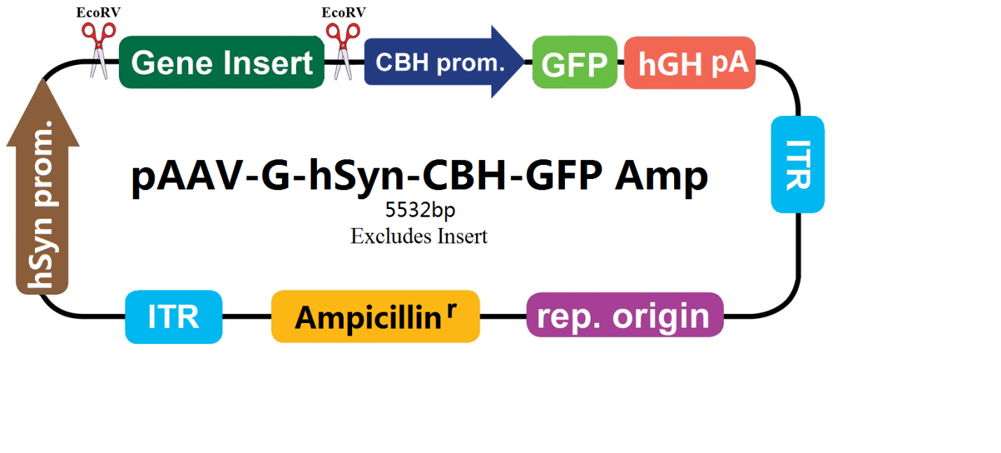 1 cctgcaggca gctgcgcgct cgctcgctca ctgaggccgc ccgggcgtcg ggcgaccttt  
61 ggtcgcccgg cctcagtgag cgagcgagcg cgcagagagg gagtggccaa ctccatcact  
121 aggggttcct gcggccgccc taggctagac tgcagagggc cctgcgtatg agtgcaagtg  
181 ggttttagga ccaggatgag gcggggtggg ggtgcctacc tgacgaccga ccccgaccca  
241 ctggacaagc acccaacccc cattccccaa attgcgcatc ccctatcaga gagggggagg  
301 ggaaacagga tgcggcgagg cgcgtgcgca ctgccagctt cagcaccgcg gacagtgcct  
361 tcgcccccgc ctggcggcgc gcgccaccgc cgcctcagca ctgaaggcgc gctgacgtca  
421 ctcgccggtc ccccgcaaac tccccttccc ggccaccttg gtcgcgtccg cgccgccgcc  
481 ggcccagccg gaccgcacca cgcgaggcgc gagatagggg ggcacgggcg cgaccatctg  
541 cgctgcggcg ccggcgactc agcgctgcct cagtctgcgg tgggcagcgg aggagtcgtg  
601 tcgtgcctga gagcgcagtc gagaagagct cgtttagtga accgtcagat cgcctggaga  
661 cgccatccac gctgttttga cctccataga agaaccgagt ttaaactccc tatcagtgat  
721 agagatctcc ctatcagtga tagagagcta gcgatatcaa caagtttgta caaaaaagct  
781 gaacgagaaa cgtaaaatga tataaatatc aatatattaa attagatttt gcataaaaaa  
841 cagactacat aatactgtaa aacacaacat atccagtcac tatggcggcc gcattaggca  
901 ccccaggctt tacactttat gcttccggct cgtataatgt gtggattttg agttaggatc  
961 cgtcgagatt ttcaggagct aaggaagcta aaatggagaa aaaaatcact ggatatacca  
1021 ccgttgatat atcccaatgg catcgtaaag aacattttga ggcatttcag tcagttgctc  
1081 aatgtaccta taaccagacc gttcagctgg atattacggc ctttttaaag accgtaaaga  
1141 aaaataagca caagttttat ccggccttta ttcacattct tgcccgcctg atgaatgctc  
1201 atccggaatt ccgtatggca atgaaagacg gtgagctggt gatatgggat agtgttcacc  
1261 cttgttacac cgttttccat gagcaaactg aaacgttttc atcgctctgg agtgaatacc  
1321 acgacgattt ccggcagttt ctacacatat attcgcaaga tgtggcgtgt tacggtgaaa  
1381 acctggccta tttccctaaa gggtttattg agaatatgtt tttcgtctca gccaatccct  
1441 gggtgagttt caccagtttt gatttaaacg tggccaatat ggacaacttc ttcgcccccg  
1501 ttttcaccat gggcaaatat tatacgcaag gcgacaaggt gctgatgccg ctggcgattc  
1561 aggttcatca tgccgtttgt gatggcttcc atgtcggcag aatgcttaat gaattacaac  
1621 agtactgcga tgagtggcag ggcggggcgt aaagatctgg atccggctta ctaaaagcca  
1681 gataacagta tgcgtatttg cgcgctgatt tttgcggtat aagaatatat actgatatgt  
1741 atacccgaag tatgtcaaaa agaggtatgc tatgaagcag cgtattacag tgacagttga  
1801 cagcgacagc tatcagttgc tcaaggcata tatgatgtca atatctccgg tctggtaagc  
1861 acaaccatgc agaatgaagc ccgtcgtctg cgtgccgaac gctggaaagc ggaaaatcag  
1921 gaagggatgg ctgaggtcgc ccggtttatt gaaatgaacg gctcttttgc tgacgagaac  
1981 aggggctggt gaaatgcagt ttaaggttta cacctataaa agagagagcc gttatcgtct  
2041 gtttgtggat gtacagagtg atattattga cacgcccggg cgacggatgg tgatccccct  
2101 ggccagtgca cgtctgctgt cagataaagt ctcccgtgaa ctttacccgg tggtgcatat  
2161 cggggatgaa agctggcgca tgatgaccac cgatatggcc agtgtgccgg tctccgttat  
2221 cggggaagaa gtggctgatc tcagccaccg cgaaaatgac atcaaaaacg ccattaacct  
2281 gatgttctgg ggaatataaa tgtcaggctc ccttatacac agccagtctg caggtcgacc  
2341 atagtgactg gatatgttgt gttttacagt attatgtagt ctgtttttta tgcaaaatct  
2401 aatttaatat attgatattt atatcatttt acgtttctcg ttcagctttc ttgtacaaag  
2461 tggttgatat ctgactcgag tataaggatg atgacgacaa atgagctagc acataactta  
2521 cggtaaatgg cccgcctggc tgaccgccca acgacccccg cccattgacg tcaatagtaa  
2581 cgccaatagg gactttccat tgacgtcaat gggtggagta tttacggtaa actgcccact  
2641 tggcagtaca tcaagtgtat catatgccaa gtacgccccc tattgacgtc aatgacggta  
2701 aatggcccgc ctggcattgt gcccagtaca tgaccttatg ggactttcct acttggcagt  
2761 acatctacgt attagtcatc gctattacca tggtcgaggt gagccccacg ttctgcttca  
2821 ctctccccat ctcccccccc tccccacccc caattttgta tttatttatt ttttaattat  
2881 tttgtgcagc gatgggggcg gggggggggg gggcgcgcgc caggcggggc ggggcggggc  
2941 gaggggcggg gcggggcgag gcggagaggt gcggcggcag ccaatcagag cggcgcgctc  
3001 caaaagtttc cttttatggc gaggcggcgg cggcggcggc cctataaaaa gcgaagcgcg  
3061 cggcgggcgg gagtcgctgc gcgctgcctt cgccccgtgc cccgctccgc cgccgcctcg  
3121 cgccgcccgc cccggctctg actgaccgcg ttactcccac aggtgagcgg gcgggacggc  
3181 ccttctcctc cgggctgtaa ttagcttcga acgccaccat ggtgagcaag ggcgaggagc  
3241 tgttcaccgg ggtggtgccc atcctggtcg agctggacgg cgacgtaaac ggccacaagt  
3301 tcagcgtgtc cggcgagggc gagggcgatg ccacctacgg caagctgacc ctgaagttca  
3361 tctgcaccac cggcaagctg cccgtgccct ggcccaccct cgtgaccacc ttgacctacg  
3421 gcgtgcagtg cttcgcccgc taccccgacc acatgaagca gcacgacttc ttcaagtccg  
3481 ccatgcccga aggctacgtc caggagcgca ccatcttctt caaggacgac ggcaactaca  
3541 agacccgcgc cgaggtgaag ttcgagggcg acaccctggt gaaccgcatc gagctgaagg  
3601 gcatcgactt caaggaggac ggcaacatcc tggggcacaa gctggagtac aactacaaca  
3661 gccacaaggt ctatatcacc gccgacaagc agaagaacgg catcaaggtg aacttcaaga  
3721 cccgccacaa catcgaggac ggcagcgtgc agctcgccga ccactaccag cagaacaccc  
3781 ccatcggcga cggccccgtg ctgctgcccg acaaccacta cctgagcacc cagtccgccc  
3841 tgagcaaaga ccccaacgag aagcgcgatc acatggtcct gctggagttc gtgaccgccg  
3901 ccgggatcac tctcggcatg gacgagctgt acaagtaact taaggggtgg catccctgtg  
3961 acccctcccc agtgcctctc ctggccctgg aagttgccac tccagtgccc accagccttg  
4021 tcctaataaa attaagttgc atcattttgt ctgactaggt gtccttctat aatattatgg  
4081 ggtggagggg ggtggtatgg agcaaggggc aagttgggaa gacaacctgt agggcctgcg  
4141 gggtctattg ggaaccaagc tggagtgcag tggcacaatc ttggctcact gcaatctccg  
4201 cctcctgggt tcaagcgatt ctcctgcctc agcctcccga gttgttggga ttccaggcat  
4261 gcatgaccag gctcagctaa tttttgtttt tttggtagag acggggtttc accatattgg  
4321 ccaggctggt ctccaactcc taatctcagg tgatctaccc accttggcct cccaaattgc  
4381 tgggattaca ggcgtgaacc actgctccct tccctgtcct tcacgtgcgg accgagcggc  
4441 cgcaggaacc cctagtgatg gagttggcca ctccctctct gcgcgctcgc tcgctcactg  
4501 aggccgggcg accaaaggtc gcccgacgcc cgggctttgc ccgggcggcc tcagtgagcg  
4561 agcgagcgcg cagctgcctg caggggcgcc tgatgcggta ttttctcctt acgcatctgt  
4621 gcggtatttc acaccgcata cgtcaaagca accatagtac gcgccctgta gcggcgcatt  
4681 aagcgcggcg ggtgtggtgg ttacgcgcag cgtgaccgct acacttgcca gcgccttagc  
4741 gcccgctcct ttcgctttct tcccttcctt tctcgccacg ttcgccggct ttccccgtca  
4801 agctctaaat cgggggctcc ctttagggtt ccgatttagt gctttacggc acctcgaccc  
4861 caaaaaactt gatttgggtg atggttcacg tagtgggcca tcgccctgat agacggtttt  
4921 tcgccctttg acgttggagt ccacgttctt taatagtgga ctcttgttcc aaactggaac  
4981 aacactcaac tctatctcgg gctattcttt tgatttataa gggattttgc cgatttcggt  
5041 ctattggtta aaaaatgagc tgatttaaca aaaatttaac gcgaatttta acaaaatatt  
5101 aacgtttaca attttatggt gcactctcag tacaatctgc tctgatgccg catagttaag  
5161 ccagccccga cacccgccaa cacccgctga cgcgccctga cgggcttgtc tgctcccggc  
5221 atccgcttac agacaagctg tgaccgtctc cgggagctgc atgtgtcaga ggttttcacc  
5281 gtcatcaccg aaacgcgcga gccgggagct gcatgtgtca gaggttttca ccgtcatcac  
5341 cgaaacgcgc gagacgaaag ggcctcgtga tacgcctatt tttataggtt aatgtcatga  
5401 taataatggt ttcttagacg tcaggtggca cttttcgggg aaatgtgcgc ggaaccccta  
5461 tttgtttatt tttctaaata cattcaaata tgtatccgct catgagacaa taaccctgat  
5521 aaatgcttca ataatattga aaaaggaaga gtatgagtat tcaacatttc cgtgtcgccc  
5581 ttattccctt ttttgcggca ttttgccttc ctgtttttgc tcacccagaa acgctggtga  
5641 aagtaaaaga tgctgaagat cagttgggtg cacgagtggg ttacatcgaa ctggatctca  
5701 acagcggtaa gatccttgag agttttcgcc ccgaagaacg ttttccaatg atgagcactt  
5761 ttaaagttct gctatgtggc gcggtattat cccgtattga cgccgggcaa gagcaactcg  
5821 gtcgccgcat acactattct cagaatgact tggttgagta ctcaccagtc acagaaaagc  
5881 atcttacgga tggcatgaca gtaagagaat tatgcagtgc tgccataacc atgagtgata  
5941 acactgcggc caacttactt ctgacaacga tcggaggacc gaaggagcta accgcttttt  
6001 tgcacaacat gggggatcat gtaactcgcc ttgatcgttg ggaaccggag ctgaatgaag  
6061 ccataccaaa cgacgagcgt gacaccacga tgcctgtagc aatggcaaca acgttgcgca  
6121 aactattaac tggcgaacta cttactctag cttcccggca acaattaata gactggatgg  
6181 aggcggataa agttgcagga ccacttctgc gctcggccct tccggctggc tggtttattg  
6241 ctgataaatc tggagccggt gagcgtgggt ctcgcggtat cattgcagca ctggggccag  
6301 atggtaagcc ctcccgtatc gtagttatct acacgacggg gagtcaggca actatggatg  
6361 aacgaaatag acagatcgct gagataggtg cctcactgat taagcattgg taactgtcag  
6421 accaagttta ctcatatata ctttagattg atttaaaact tcatttttaa tttaaaagga  
6481 tctaggtgaa gatccttttt gataatctca tgaccaaaat cccttaacgt gagttttcgt  
6541 tccactgagc gtcagacccc gtagaaaaga tcaaaggatc ttcttgagat cctttttttc  
6601 tgcgcgtaat ctgctgcttg caaacaaaaa aaccaccgct accagcggtg gtttgtttgc  
6661 cggatcaaga gctaccaact ctttttccga aggtaactgg cttcagcaga gcgcagatac  
6721 caaatactgt tcttctagtg tagccgtagt taggccacca cttcaagaac tctgtagcac  
6781 cgcctacata cctcgctctg ctaatcctgt taccagtggc tgctgccagt ggcgataagt  
6841 cgtgtcttac cgggttggac tcaagacgat agttaccgga taaggcgcag cggtcgggct  
6901 gaacgggggg ttcgtgcaca cagcccagct tggagcgaac gacctacacc gaactgagat  
6961 acctacagcg tgagctatga gaaagcgcca cgcttcccga agggagaaag gcggacaggt  
7021 atccggtaag cggcagggtc ggaacaggag agcgcacgag ggagcttcca gggggaaacg  
7081 cctggtatct ttatagtcct gtcgggtttc gccacctctg acttgagcgt cgatttttgt  
7141 gatgctcgtc aggggggcgg agcctatgga aaaacgccag caacgcggcc tttttacggt  
7201 tcctggcctt ttgctggcct tttgctcaca tgt

**4. pAAV-G-PGK-CBH-gcGFP-hGH-amp**

<https://old.abmgood.com/vectors/vectorDisplay.php?vec=pAAV-G-PGK-CBH-gcGFP-hGH-amp&page=map>

|  |  |
| --- | --- |
| **Vector Name** | **pAAV-G-PGK-CBH-gcGFP-hGH-amp** |
| **VectorType** | AAV Plasmid |
| **Antibiotic Information** | Ampicillin |
| **Sequencing Primers** | PGK forward 5'---AAT TCT ACC GGG TAG GGG AGG CGC T---3' |
| **Additional Information** | No Additional Information |

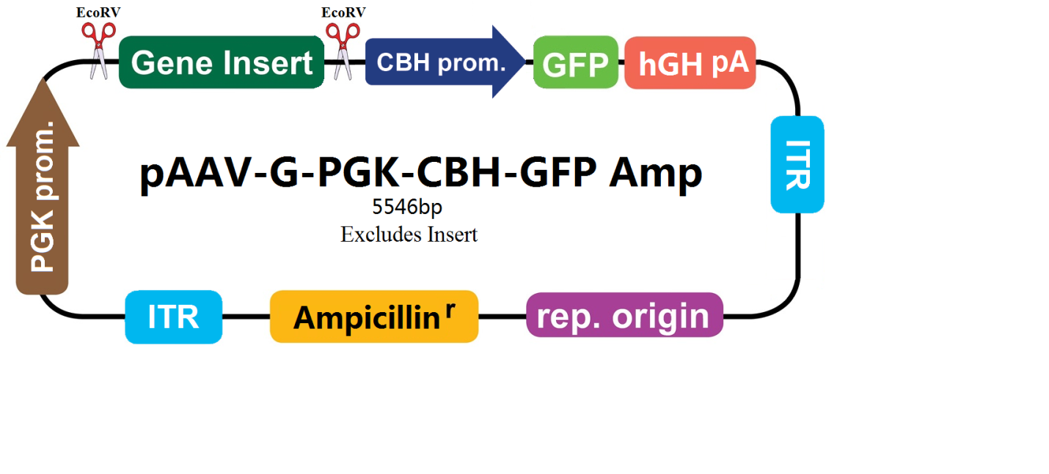

1 cctgcaggca gctgcgcgct cgctcgctca ctgaggccgc ccgggcgtcg ggcgaccttt  
61 ggtcgcccgg cctcagtgag cgagcgagcg cgcagagagg gagtggccaa ctccatcact  
121 aggggttcct gcggccgccc tagggggtag gggaggcgct tttcccaagg cagtctggag  
181 catgcgcttt agcagccccg ctgggcactt ggcgctacac aagtggcctc tggcctcgca  
241 cacattccac atccaccggt aggcgccaac cggctccgtt ctttggtggc cccttcgcgc  
301 caccttctac tcctccccta gtcaggaagt tcccccccgc cccgcagctc gcgtcgtgca  
361 ggacgtgaca aatggaagta gcacgtctca ctagtctcgt gcagatggac agcaccgctg  
421 agcaatggaa gcgggtaggc ctttggggca gcggccaata gcagctttgc tccttcgctt  
481 tctgggctca gaggctggga aggggtgggt ccgggggcgg gctcaggggc gggctcaggg  
541 gcggggcggg cgcccgaagg tcctccggag gcccggcatt ctgcacgctt caaaagcgca  
601 cgtctgccgc gctgttctcc tcttcctcat ctccgggcct ttcggagctc gtttagtgaa  
661 ccgtcagatc gcctggagac gccatccacg ctgttttgac ctccatagaa gaaccgagtt  
721 taaactccct atcagtgata gagatctccc tatcagtgat agagagctag cgatatcaac  
781 aagtttgtac aaaaaagctg aacgagaaac gtaaaatgat ataaatatca atatattaaa  
841 ttagattttg cataaaaaac agactacata atactgtaaa acacaacata tccagtcact  
901 atggcggccg cattaggcac cccaggcttt acactttatg cttccggctc gtataatgtg  
961 tggattttga gttaggatcc gtcgagattt tcaggagcta aggaagctaa aatggagaaa  
1021 aaaatcactg gatataccac cgttgatata tcccaatggc atcgtaaaga acattttgag  
1081 gcatttcagt cagttgctca atgtacctat aaccagaccg ttcagctgga tattacggcc  
1141 tttttaaaga ccgtaaagaa aaataagcac aagttttatc cggcctttat tcacattctt  
1201 gcccgcctga tgaatgctca tccggaattc cgtatggcaa tgaaagacgg tgagctggtg  
1261 atatgggata gtgttcaccc ttgttacacc gttttccatg agcaaactga aacgttttca  
1321 tcgctctgga gtgaatacca cgacgatttc cggcagtttc tacacatata ttcgcaagat  
1381 gtggcgtgtt acggtgaaaa cctggcctat ttccctaaag ggtttattga gaatatgttt  
1441 ttcgtctcag ccaatccctg ggtgagtttc accagttttg atttaaacgt ggccaatatg  
1501 gacaacttct tcgcccccgt tttcaccatg ggcaaatatt atacgcaagg cgacaaggtg  
1561 ctgatgccgc tggcgattca ggttcatcat gccgtttgtg atggcttcca tgtcggcaga  
1621 atgcttaatg aattacaaca gtactgcgat gagtggcagg gcggggcgta aagatctgga  
1681 tccggcttac taaaagccag ataacagtat gcgtatttgc gcgctgattt ttgcggtata  
1741 agaatatata ctgatatgta tacccgaagt atgtcaaaaa gaggtatgct atgaagcagc  
1801 gtattacagt gacagttgac agcgacagct atcagttgct caaggcatat atgatgtcaa  
1861 tatctccggt ctggtaagca caaccatgca gaatgaagcc cgtcgtctgc gtgccgaacg  
1921 ctggaaagcg gaaaatcagg aagggatggc tgaggtcgcc cggtttattg aaatgaacgg  
1981 ctcttttgct gacgagaaca ggggctggtg aaatgcagtt taaggtttac acctataaaa  
2041 gagagagccg ttatcgtctg tttgtggatg tacagagtga tattattgac acgcccgggc  
2101 gacggatggt gatccccctg gccagtgcac gtctgctgtc agataaagtc tcccgtgaac  
2161 tttacccggt ggtgcatatc ggggatgaaa gctggcgcat gatgaccacc gatatggcca  
2221 gtgtgccggt ctccgttatc ggggaagaag tggctgatct cagccaccgc gaaaatgaca  
2281 tcaaaaacgc cattaacctg atgttctggg gaatataaat gtcaggctcc cttatacaca  
2341 gccagtctgc aggtcgacca tagtgactgg atatgttgtg ttttacagta ttatgtagtc  
2401 tgttttttat gcaaaatcta atttaatata ttgatattta tatcatttta cgtttctcgt  
2461 tcagctttct tgtacaaagt ggttgatatc tgactcgagt ataaggatga tgacgacaaa  
2521 tgagctagca cataacttac ggtaaatggc ccgcctggct gaccgcccaa cgacccccgc  
2581 ccattgacgt caatagtaac gccaataggg actttccatt gacgtcaatg ggtggagtat  
2641 ttacggtaaa ctgcccactt ggcagtacat caagtgtatc atatgccaag tacgccccct  
2701 attgacgtca atgacggtaa atggcccgcc tggcattgtg cccagtacat gaccttatgg  
2761 gactttccta cttggcagta catctacgta ttagtcatcg ctattaccat ggtcgaggtg  
2821 agccccacgt tctgcttcac tctccccatc tcccccccct ccccaccccc aattttgtat  
2881 ttatttattt tttaattatt ttgtgcagcg atgggggcgg gggggggggg ggcgcgcgcc  
2941 aggcggggcg gggcggggcg aggggcgggg cggggcgagg cggagaggtg cggcggcagc  
3001 caatcagagc ggcgcgctcc aaaagtttcc ttttatggcg aggcggcggc ggcggcggcc  
3061 ctataaaaag cgaagcgcgc ggcgggcggg agtcgctgcg cgctgccttc gccccgtgcc  
3121 ccgctccgcc gccgcctcgc gccgcccgcc ccggctctga ctgaccgcgt tactcccaca  
3181 ggtgagcggg cgggacggcc cttctcctcc gggctgtaat tagcttcgaa cgccaccatg  
3241 gtgagcaagg gcgaggagct gttcaccggg gtggtgccca tcctggtcga gctggacggc  
3301 gacgtaaacg gccacaagtt cagcgtgtcc ggcgagggcg agggcgatgc cacctacggc  
3361 aagctgaccc tgaagttcat ctgcaccacc ggcaagctgc ccgtgccctg gcccaccctc  
3421 gtgaccacct tgacctacgg cgtgcagtgc ttcgcccgct accccgacca catgaagcag  
3481 cacgacttct tcaagtccgc catgcccgaa ggctacgtcc aggagcgcac catcttcttc  
3541 aaggacgacg gcaactacaa gacccgcgcc gaggtgaagt tcgagggcga caccctggtg  
3601 aaccgcatcg agctgaaggg catcgacttc aaggaggacg gcaacatcct ggggcacaag  
3661 ctggagtaca actacaacag ccacaaggtc tatatcaccg ccgacaagca gaagaacggc  
3721 atcaaggtga acttcaagac ccgccacaac atcgaggacg gcagcgtgca gctcgccgac  
3781 cactaccagc agaacacccc catcggcgac ggccccgtgc tgctgcccga caaccactac  
3841 ctgagcaccc agtccgccct gagcaaagac cccaacgaga agcgcgatca catggtcctg  
3901 ctggagttcg tgaccgccgc cgggatcact ctcggcatgg acgagctgta caagtaactt  
3961 aaggggtggc atccctgtga cccctcccca gtgcctctcc tggccctgga agttgccact  
4021 ccagtgccca ccagccttgt cctaataaaa ttaagttgca tcattttgtc tgactaggtg  
4081 tccttctata atattatggg gtggaggggg gtggtatgga gcaaggggca agttgggaag  
4141 acaacctgta gggcctgcgg ggtctattgg gaaccaagct ggagtgcagt ggcacaatct  
4201 tggctcactg caatctccgc ctcctgggtt caagcgattc tcctgcctca gcctcccgag  
4261 ttgttgggat tccaggcatg catgaccagg ctcagctaat ttttgttttt ttggtagaga  
4321 cggggtttca ccatattggc caggctggtc tccaactcct aatctcaggt gatctaccca  
4381 ccttggcctc ccaaattgct gggattacag gcgtgaacca ctgctccctt ccctgtcctt  
4441 cacgtgcgga ccgagcggcc gcaggaaccc ctagtgatgg agttggccac tccctctctg  
4501 cgcgctcgct cgctcactga ggccgggcga ccaaaggtcg cccgacgccc gggctttgcc  
4561 cgggcggcct cagtgagcga gcgagcgcgc agctgcctgc aggggcgcct gatgcggtat  
4621 tttctcctta cgcatctgtg cggtatttca caccgcatac gtcaaagcaa ccatagtacg  
4681 cgccctgtag cggcgcatta agcgcggcgg gtgtggtggt tacgcgcagc gtgaccgcta  
4741 cacttgccag cgccttagcg cccgctcctt tcgctttctt cccttccttt ctcgccacgt  
4801 tcgccggctt tccccgtcaa gctctaaatc gggggctccc tttagggttc cgatttagtg  
4861 ctttacggca cctcgacccc aaaaaacttg atttgggtga tggttcacgt agtgggccat  
4921 cgccctgata gacggttttt cgccctttga cgttggagtc cacgttcttt aatagtggac  
4981 tcttgttcca aactggaaca acactcaact ctatctcggg ctattctttt gatttataag  
5041 ggattttgcc gatttcggtc tattggttaa aaaatgagct gatttaacaa aaatttaacg  
5101 cgaattttaa caaaatatta acgtttacaa ttttatggtg cactctcagt acaatctgct  
5161 ctgatgccgc atagttaagc cagccccgac acccgccaac acccgctgac gcgccctgac  
5221 gggcttgtct gctcccggca tccgcttaca gacaagctgt gaccgtctcc gggagctgca  
5281 tgtgtcagag gttttcaccg tcatcaccga aacgcgcgag ccgggagctg catgtgtcag  
5341 aggttttcac cgtcatcacc gaaacgcgcg agacgaaagg gcctcgtgat acgcctattt  
5401 ttataggtta atgtcatgat aataatggtt tcttagacgt caggtggcac ttttcgggga  
5461 aatgtgcgcg gaacccctat ttgtttattt ttctaaatac attcaaatat gtatccgctc  
5521 atgagacaat aaccctgata aatgcttcaa taatattgaa aaaggaagag tatgagtatt  
5581 caacatttcc gtgtcgccct tattcccttt tttgcggcat tttgccttcc tgtttttgct  
5641 cacccagaaa cgctggtgaa agtaaaagat gctgaagatc agttgggtgc acgagtgggt  
5701 tacatcgaac tggatctcaa cagcggtaag atccttgaga gttttcgccc cgaagaacgt  
5761 tttccaatga tgagcacttt taaagttctg ctatgtggcg cggtattatc ccgtattgac  
5821 gccgggcaag agcaactcgg tcgccgcata cactattctc agaatgactt ggttgagtac  
5881 tcaccagtca cagaaaagca tcttacggat ggcatgacag taagagaatt atgcagtgct  
5941 gccataacca tgagtgataa cactgcggcc aacttacttc tgacaacgat cggaggaccg  
6001 aaggagctaa ccgctttttt gcacaacatg ggggatcatg taactcgcct tgatcgttgg  
6061 gaaccggagc tgaatgaagc cataccaaac gacgagcgtg acaccacgat gcctgtagca  
6121 atggcaacaa cgttgcgcaa actattaact ggcgaactac ttactctagc ttcccggcaa  
6181 caattaatag actggatgga ggcggataaa gttgcaggac cacttctgcg ctcggccctt  
6241 ccggctggct ggtttattgc tgataaatct ggagccggtg agcgtgggtc tcgcggtatc  
6301 attgcagcac tggggccaga tggtaagccc tcccgtatcg tagttatcta cacgacgggg  
6361 agtcaggcaa ctatggatga acgaaataga cagatcgctg agataggtgc ctcactgatt  
6421 aagcattggt aactgtcaga ccaagtttac tcatatatac tttagattga tttaaaactt  
6481 catttttaat ttaaaaggat ctaggtgaag atcctttttg ataatctcat gaccaaaatc  
6541 ccttaacgtg agttttcgtt ccactgagcg tcagaccccg tagaaaagat caaaggatct  
6601 tcttgagatc ctttttttct gcgcgtaatc tgctgcttgc aaacaaaaaa accaccgcta  
6661 ccagcggtgg tttgtttgcc ggatcaagag ctaccaactc tttttccgaa ggtaactggc  
6721 ttcagcagag cgcagatacc aaatactgtt cttctagtgt agccgtagtt aggccaccac  
6781 ttcaagaact ctgtagcacc gcctacatac ctcgctctgc taatcctgtt accagtggct  
6841 gctgccagtg gcgataagtc gtgtcttacc gggttggact caagacgata gttaccggat  
6901 aaggcgcagc ggtcgggctg aacggggggt tcgtgcacac agcccagctt ggagcgaacg  
6961 acctacaccg aactgagata cctacagcgt gagctatgag aaagcgccac gcttcccgaa  
7021 gggagaaagg cggacaggta tccggtaagc ggcagggtcg gaacaggaga gcgcacgagg  
7081 gagcttccag ggggaaacgc ctggtatctt tatagtcctg tcgggtttcg ccacctctga  
7141 cttgagcgtc gatttttgtg atgctcgtca ggggggcgga gcctatggaa aaacgccagc  
7201 aacgcggcct ttttacggtt cctggccttt tgctggcctt ttgctcacat gt

**5. pAAV-G-CAGGS-CBH-gcGFP-hGH-amp**

<https://old.abmgood.com/vectors/vectorDisplay.php?vec=pAAV-G-CAGGS-CBH-gcGFP-hGH-amp&page=prop>

|  |  |
| --- | --- |
| **Vector Name** | **pAAV-G-CAGGS-CBH-gcGFP-hGH-amp** |
| **VectorType** | AAV Plasmid |
| **Antibiotic Information** | Ampicillin |
| **Sequencing Primers** | CAGGS forward 5'--cgcgctccgaaagtttcct--3' |
| **Additional Information** | No Additional Information |
|  |  |

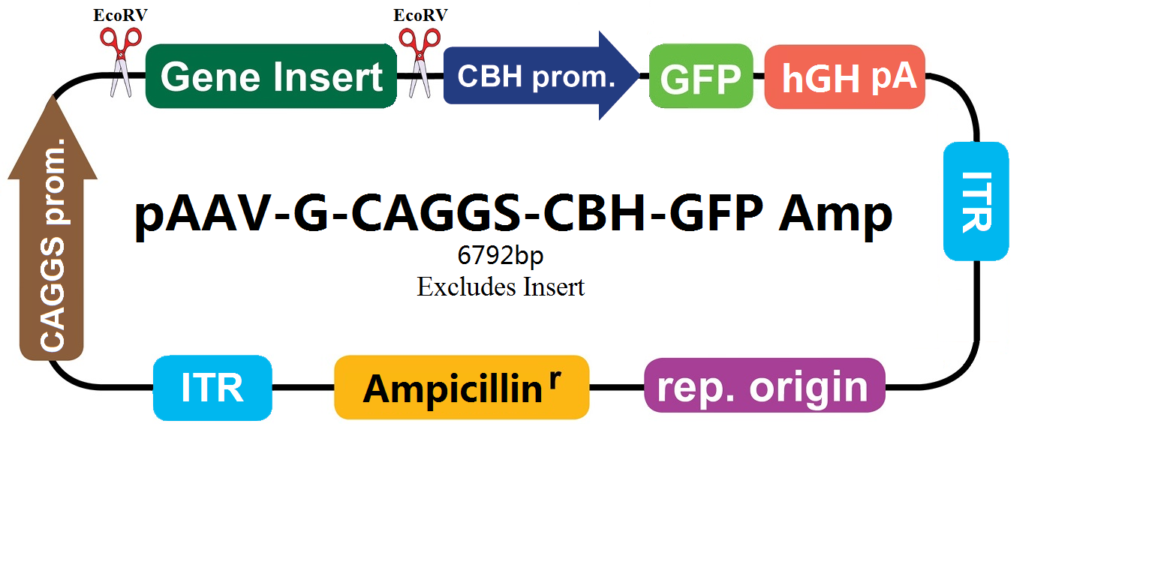

1 cctgcaggca gctgcgcgct cgctcgctca ctgaggccgc ccgggcgtcg ggcgaccttt  
61 ggtcgcccgg cctcagtgag cgagcgagcg cgcagagagg gagtggccaa ctccatcact  
121 aggggttcct gcggccgccc taggccggcc acgcgtggcg cgttgacatt gattattgac  
181 tagttattaa tagtaatcaa ttacggggtc attagttcat agcccatata tggagttccg  
241 cgttacataa cttacggtaa atggcccgcc tggctgaccg cccaacgacc cccgcccatt  
301 gacgtcaata atgacgtatg ttcccatagt aacgccaata gggactttcc attgacgtca  
361 atgggtggac tatttacggt aaactgccca cttggcagta catcaagtgt atcatatgcc  
421 aagtacgccc cctattgacg tcaatgacgg taaatggccc gcctggcatt atgcccagta  
481 catgacctta tgggactttc ctacttggca gtacatctac gtattagtca tcgctattac  
541 catgggtcga ggtgagcccc acgttctgct tcactctccc catctccccc ccctccccac  
601 ccccaatttt gtatttattt attttttaat tattttgtgc agcgatgggg gcgggggggg  
661 gggggcgcgc gccaggcggg gcggggcggg gcgaggggcg gggcggggcg aggcggagag  
721 gtgcggcggc agccaatcag agcggcgcgc tccgaaagtt tccttttatg gcgaggcggc  
781 ggcggcggcg gccctataaa aagcgaagcg cgcggcgggc gggagtcgct gcgttgcctt  
841 cgccccgtgc cccgctccgc gccgcctcgc gccgcccgcc ccggctctga ctgaccgcgt  
901 tactcccaca ggtgagcggg cgggacggcc cttctcctcc gggctgtaat tagcgcttgg  
961 tttaatgacg gctcgtttct tttctgtggc tgcgtgaaag ccttaaaggg ctccgggagg  
1021 gccctttgtg cgggggggag cggctcgggg ggtgcgtgcg tgtgtgtgtg cgtggggagc  
1081 gccgcgtgcg gcccgcgctg cccggcggct gtgagcgctg cgggcgcggc gcggggcttt  
1141 gtgcgctccg cgtgtgcgcg aggggagcgc ggccgggggc ggtgccccgc ggtgcggggg  
1201 ggctgcgagg ggaacaaagg ctgcgtgcgg ggtgtgtgcg tgggggggtg agcagggggt  
1261 gtgggcgcgg cggtcgggct gtaacccccc cctgcacccc cctccccgag ttgctgagca  
1321 cggcccggct tcgggtgcgg ggctccgtgc ggggcgtggc gcggggctcg ccgtgccggg  
1381 cggggggtgg cggcaggtgg gggtgccggg cggggcgggg ccgcctcggg ccggggaggg  
1441 ctcgggggag gggcgcggcg gccccggagc gccggcggct gtcgaggcgc ggcgagccgc  
1501 agccattgcc ttttatggta atcgtgcgag agggcgcagg gacttccttt gtcccaaatc  
1561 tggcggagcc gaaatctggg aggcgccgcc gcaccccctc tagcgggcgc gggcgaagcg  
1621 gtgcggcgcc ggcaggaagg aaatgggcgg ggagggcctt cgtgcgtcgc cgcgccgccg  
1681 tccccttctc catctccagc ctcggggctg ccgcaggggg acggctgcct tcggggggga  
1741 cggggcaggg cggggttcgg cttctggcgt gtgaccggcg gctctagagc ctctgctaac  
1801 catgttcatg ccttcttctt tttcctacag ctcctgggca acgtgctggt tgttgtgctg  
1861 tctcatcatt ttggcaaaga attggcgcgc cgagctcgtt tagtgaaccg tcagatcgcc  
1921 tggagacgcc atccacgctg ttttgacctc catagaagaa ccgagtttaa actccctatc  
1981 agtgatagag atctccctat cagtgataga gagctagcga tatcaacaag tttgtacaaa  
2041 aaagctgaac gagaaacgta aaatgatata aatatcaata tattaaatta gattttgcat  
2101 aaaaaacaga ctacataata ctgtaaaaca caacatatcc agtcactatg gcggccgcat  
2161 taggcacccc aggctttaca ctttatgctt ccggctcgta taatgtgtgg attttgagtt  
2221 aggatccgtc gagattttca ggagctaagg aagctaaaat ggagaaaaaa atcactggat  
2281 ataccaccgt tgatatatcc caatggcatc gtaaagaaca ttttgaggca tttcagtcag  
2341 ttgctcaatg tacctataac cagaccgttc agctggatat tacggccttt ttaaagaccg  
2401 taaagaaaaa taagcacaag ttttatccgg cctttattca cattcttgcc cgcctgatga  
2461 atgctcatcc ggaattccgt atggcaatga aagacggtga gctggtgata tgggatagtg  
2521 ttcacccttg ttacaccgtt ttccatgagc aaactgaaac gttttcatcg ctctggagtg  
2581 aataccacga cgatttccgg cagtttctac acatatattc gcaagatgtg gcgtgttacg  
2641 gtgaaaacct ggcctatttc cctaaagggt ttattgagaa tatgtttttc gtctcagcca  
2701 atccctgggt gagtttcacc agttttgatt taaacgtggc caatatggac aacttcttcg  
2761 cccccgtttt caccatgggc aaatattata cgcaaggcga caaggtgctg atgccgctgg  
2821 cgattcaggt tcatcatgcc gtttgtgatg gcttccatgt cggcagaatg cttaatgaat  
2881 tacaacagta ctgcgatgag tggcagggcg gggcgtaaag atctggatcc ggcttactaa  
2941 aagccagata acagtatgcg tatttgcgcg ctgatttttg cggtataaga atatatactg  
3001 atatgtatac ccgaagtatg tcaaaaagag gtatgctatg aagcagcgta ttacagtgac  
3061 agttgacagc gacagctatc agttgctcaa ggcatatatg atgtcaatat ctccggtctg  
3121 gtaagcacaa ccatgcagaa tgaagcccgt cgtctgcgtg ccgaacgctg gaaagcggaa  
3181 aatcaggaag ggatggctga ggtcgcccgg tttattgaaa tgaacggctc ttttgctgac  
3241 gagaacaggg gctggtgaaa tgcagtttaa ggtttacacc tataaaagag agagccgtta  
3301 tcgtctgttt gtggatgtac agagtgatat tattgacacg cccgggcgac ggatggtgat  
3361 ccccctggcc agtgcacgtc tgctgtcaga taaagtctcc cgtgaacttt acccggtggt  
3421 gcatatcggg gatgaaagct ggcgcatgat gaccaccgat atggccagtg tgccggtctc  
3481 cgttatcggg gaagaagtgg ctgatctcag ccaccgcgaa aatgacatca aaaacgccat  
3541 taacctgatg ttctggggaa tataaatgtc aggctccctt atacacagcc agtctgcagg  
3601 tcgaccatag tgactggata tgttgtgttt tacagtatta tgtagtctgt tttttatgca  
3661 aaatctaatt taatatattg atatttatat cattttacgt ttctcgttca gctttcttgt  
3721 acaaagtggt tgatatctga ctcgagtata aggatgatga cgacaaatga gctagcacat  
3781 aacttacggt aaatggcccg cctggctgac cgcccaacga cccccgccca ttgacgtcaa  
3841 tagtaacgcc aatagggact ttccattgac gtcaatgggt ggagtattta cggtaaactg  
3901 cccacttggc agtacatcaa gtgtatcata tgccaagtac gccccctatt gacgtcaatg  
3961 acggtaaatg gcccgcctgg cattgtgccc agtacatgac cttatgggac tttcctactt  
4021 ggcagtacat ctacgtatta gtcatcgcta ttaccatggt cgaggtgagc cccacgttct  
4081 gcttcactct ccccatctcc cccccctccc cacccccaat tttgtattta tttatttttt  
4141 aattattttg tgcagcgatg ggggcggggg gggggggggc gcgcgccagg cggggcgggg  
4201 cggggcgagg ggcggggcgg ggcgaggcgg agaggtgcgg cggcagccaa tcagagcggc  
4261 gcgctccaaa agtttccttt tatggcgagg cggcggcggc ggcggcccta taaaaagcga  
4321 agcgcgcggc gggcgggagt cgctgcgcgc tgccttcgcc ccgtgccccg ctccgccgcc  
4381 gcctcgcgcc gcccgccccg gctctgactg accgcgttac tcccacaggt gagcgggcgg  
4441 gacggccctt ctcctccggg ctgtaattag cttcgaacgc caccatggtg agcaagggcg  
4501 aggagctgtt caccggggtg gtgcccatcc tggtcgagct ggacggcgac gtaaacggcc  
4561 acaagttcag cgtgtccggc gagggcgagg gcgatgccac ctacggcaag ctgaccctga  
4621 agttcatctg caccaccggc aagctgcccg tgccctggcc caccctcgtg accaccttga  
4681 cctacggcgt gcagtgcttc gcccgctacc ccgaccacat gaagcagcac gacttcttca  
4741 agtccgccat gcccgaaggc tacgtccagg agcgcaccat cttcttcaag gacgacggca  
4801 actacaagac ccgcgccgag gtgaagttcg agggcgacac cctggtgaac cgcatcgagc  
4861 tgaagggcat cgacttcaag gaggacggca acatcctggg gcacaagctg gagtacaact  
4921 acaacagcca caaggtctat atcaccgccg acaagcagaa gaacggcatc aaggtgaact  
4981 tcaagacccg ccacaacatc gaggacggca gcgtgcagct cgccgaccac taccagcaga  
5041 acacccccat cggcgacggc cccgtgctgc tgcccgacaa ccactacctg agcacccagt  
5101 ccgccctgag caaagacccc aacgagaagc gcgatcacat ggtcctgctg gagttcgtga  
5161 ccgccgccgg gatcactctc ggcatggacg agctgtacaa gtaacttaag gggtggcatc  
5221 cctgtgaccc ctccccagtg cctctcctgg ccctggaagt tgccactcca gtgcccacca  
5281 gccttgtcct aataaaatta agttgcatca ttttgtctga ctaggtgtcc ttctataata  
5341 ttatggggtg gaggggggtg gtatggagca aggggcaagt tgggaagaca acctgtaggg  
5401 cctgcggggt ctattgggaa ccaagctgga gtgcagtggc acaatcttgg ctcactgcaa  
5461 tctccgcctc ctgggttcaa gcgattctcc tgcctcagcc tcccgagttg ttgggattcc  
5521 aggcatgcat gaccaggctc agctaatttt tgtttttttg gtagagacgg ggtttcacca  
5581 tattggccag gctggtctcc aactcctaat ctcaggtgat ctacccacct tggcctccca  
5641 aattgctggg attacaggcg tgaaccactg ctcccttccc tgtccttcac gtgcggaccg  
5701 agcggccgca ggaaccccta gtgatggagt tggccactcc ctctctgcgc gctcgctcgc  
5761 tcactgaggc cgggcgacca aaggtcgccc gacgcccggg ctttgcccgg gcggcctcag  
5821 tgagcgagcg agcgcgcagc tgcctgcagg ggcgcctgat gcggtatttt ctccttacgc  
5881 atctgtgcgg tatttcacac cgcatacgtc aaagcaacca tagtacgcgc cctgtagcgg  
5941 cgcattaagc gcggcgggtg tggtggttac gcgcagcgtg accgctacac ttgccagcgc  
6001 cttagcgccc gctcctttcg ctttcttccc ttcctttctc gccacgttcg ccggctttcc  
6061 ccgtcaagct ctaaatcggg ggctcccttt agggttccga tttagtgctt tacggcacct  
6121 cgaccccaaa aaacttgatt tgggtgatgg ttcacgtagt gggccatcgc cctgatagac  
6181 ggtttttcgc cctttgacgt tggagtccac gttctttaat agtggactct tgttccaaac  
6241 tggaacaaca ctcaactcta tctcgggcta ttcttttgat ttataaggga ttttgccgat  
6301 ttcggtctat tggttaaaaa atgagctgat ttaacaaaaa tttaacgcga attttaacaa  
6361 aatattaacg tttacaattt tatggtgcac tctcagtaca atctgctctg atgccgcata  
6421 gttaagccag ccccgacacc cgccaacacc cgctgacgcg ccctgacggg cttgtctgct  
6481 cccggcatcc gcttacagac aagctgtgac cgtctccggg agctgcatgt gtcagaggtt  
6541 ttcaccgtca tcaccgaaac gcgcgagccg ggagctgcat gtgtcagagg ttttcaccgt  
6601 catcaccgaa acgcgcgaga cgaaagggcc tcgtgatacg cctattttta taggttaatg  
6661 tcatgataat aatggtttct tagacgtcag gtggcacttt tcggggaaat gtgcgcggaa  
6721 cccctatttg tttatttttc taaatacatt caaatatgta tccgctcatg agacaataac  
6781 cctgataaat gcttcaataa tattgaaaaa ggaagagtat gagtattcaa catttccgtg  
6841 tcgcccttat tccctttttt gcggcatttt gccttcctgt ttttgctcac ccagaaacgc  
6901 tggtgaaagt aaaagatgct gaagatcagt tgggtgcacg agtgggttac atcgaactgg  
6961 atctcaacag cggtaagatc cttgagagtt ttcgccccga agaacgtttt ccaatgatga  
7021 gcacttttaa agttctgcta tgtggcgcgg tattatcccg tattgacgcc gggcaagagc  
7081 aactcggtcg ccgcatacac tattctcaga atgacttggt tgagtactca ccagtcacag  
7141 aaaagcatct tacggatggc atgacagtaa gagaattatg cagtgctgcc ataaccatga  
7201 gtgataacac tgcggccaac ttacttctga caacgatcgg aggaccgaag gagctaaccg  
7261 cttttttgca caacatgggg gatcatgtaa ctcgccttga tcgttgggaa ccggagctga  
7321 atgaagccat accaaacgac gagcgtgaca ccacgatgcc tgtagcaatg gcaacaacgt  
7381 tgcgcaaact attaactggc gaactactta ctctagcttc ccggcaacaa ttaatagact  
7441 ggatggaggc ggataaagtt gcaggaccac ttctgcgctc ggcccttccg gctggctggt  
7501 ttattgctga taaatctgga gccggtgagc gtgggtctcg cggtatcatt gcagcactgg  
7561 ggccagatgg taagccctcc cgtatcgtag ttatctacac gacggggagt caggcaacta  
7621 tggatgaacg aaatagacag atcgctgaga taggtgcctc actgattaag cattggtaac  
7681 tgtcagacca agtttactca tatatacttt agattgattt aaaacttcat ttttaattta  
7741 aaaggatcta ggtgaagatc ctttttgata atctcatgac caaaatccct taacgtgagt  
7801 tttcgttcca ctgagcgtca gaccccgtag aaaagatcaa aggatcttct tgagatcctt  
7861 tttttctgcg cgtaatctgc tgcttgcaaa caaaaaaacc accgctacca gcggtggttt  
7921 gtttgccgga tcaagagcta ccaactcttt ttccgaaggt aactggcttc agcagagcgc  
7981 agataccaaa tactgttctt ctagtgtagc cgtagttagg ccaccacttc aagaactctg  
8041 tagcaccgcc tacatacctc gctctgctaa tcctgttacc agtggctgct gccagtggcg  
8101 ataagtcgtg tcttaccggg ttggactcaa gacgatagtt accggataag gcgcagcggt  
8161 cgggctgaac ggggggttcg tgcacacagc ccagcttgga gcgaacgacc tacaccgaac  
8221 tgagatacct acagcgtgag ctatgagaaa gcgccacgct tcccgaaggg agaaaggcgg  
8281 acaggtatcc ggtaagcggc agggtcggaa caggagagcg cacgagggag cttccagggg  
8341 gaaacgcctg gtatctttat agtcctgtcg ggtttcgcca cctctgactt gagcgtcgat  
8401 ttttgtgatg ctcgtcaggg gggcggagcc tatggaaaaa cgccagcaac gcggcctttt  
8461 tacggttcct ggccttttgc tggccttttg ctcacatgt